Operating Systems Lab File



School of Engineering and Technology
Course Code & Name: ENCS351 Operating System
Program Name: BTech CSE

Name: Harshit Chaurasia Submitted to – Mr Satinder Pal Singh
Roll Number: 2301010210
Course: BTech CSE
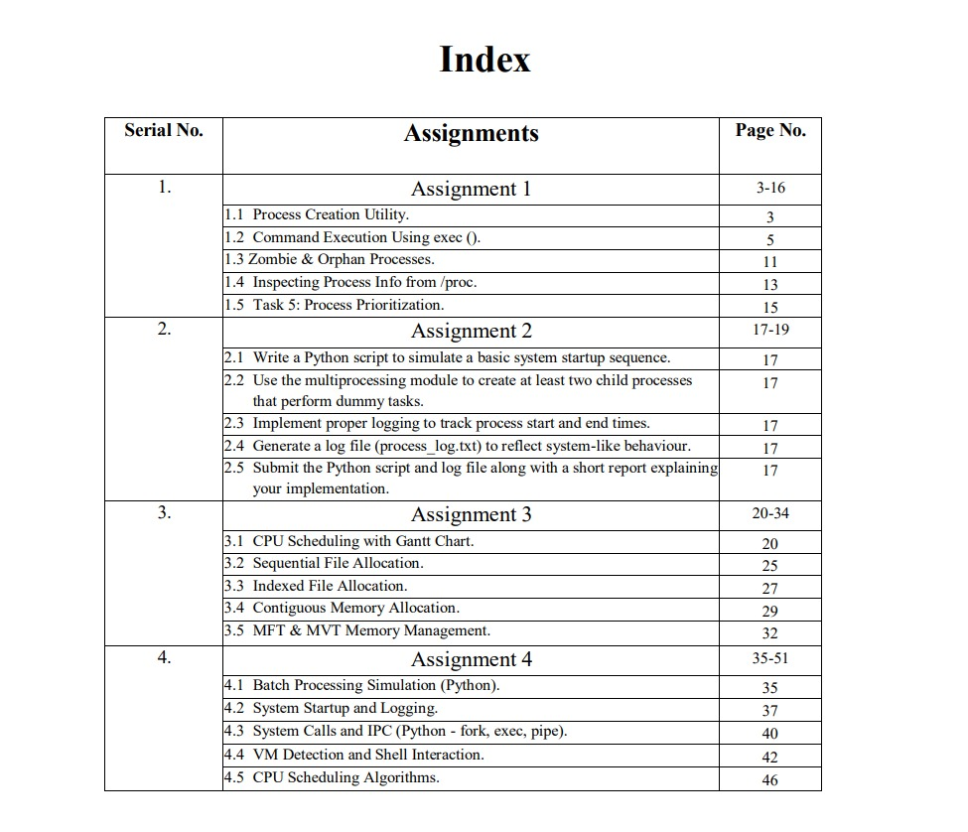

Lab Experiment 1
Experiment Title: Process Creation and Management Using Python OS Module

Experiment Objectives:

In this assignment, students will simulate Linux process management operations using Python. The experiment focuses on replicating the behaviors of fork(), exec(), and process state inspections using the os and subprocess modules in Python. It provides an understanding of process creation, child-parent relationship, and zombie/orphan process scenarios.

Learning Outcomes:
- Understand the lifecycle of processes in Linux.
- Create child processes and execute system commands using Python.
- Simulate zombie and orphan processes.
- Inspect running processes using /proc.
- Demonstrate priority setting via nice values.

Concepts Used:
- os.fork(), os.getpid(), os.getppid()
- os._exit(), os.wait(), os.nice()
- subprocess.run(), os.execvp()
- Reading /proc/[pid]/status, /exe, and /fd

Task 1: Process Creation Utility
Code:
import subprocess
def main():
n = int(input("Enter number of child processes to create: "))
processes = []
for i in range(n):
# Start independent process running 'python -c' to print info
proc = subprocess.Popen(["python", "-c",
f"import os; print('Child {i}: PID', os.getpid(), 'Parent PID', os.getppid(), 'Hello from child {i}')"])
processes.append(proc)
for proc in processes:
proc.wait()
print(f"Process with PID {proc.pid} finished.")
if __name__ == "__main__":
main()

Output:
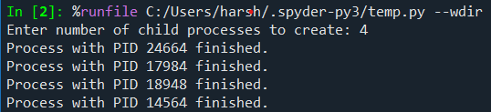

Task 2: Command Execution Using exec()

Code:
import subprocess

def main():
try:
n = int(input("Enter number of child processes to create: "))
except ValueError:
print("Please enter a valid integer.")
return

commands = [["dir"], ["date", "/t"], ["tasklist"]] # Windows commands similar to ls, date, ps

procs = []

for i in range(n):
command = commands[i % len(commands)]
print(f"Starting child {i} running command: {' '.join(command)}")
proc = subprocess.Popen(command, shell=True)
procs.append(proc)

for proc in procs:
proc.wait()
print(f"Process with PID {proc.pid} finished.")

if __name__ == "__main__":
main()
Output:
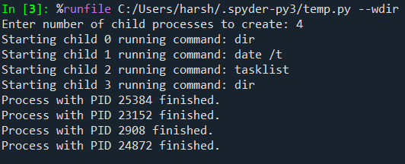

Task 3: Zombie & Orphan Processes

Code:
import subprocess
import time

def zombie_sim():
print("Zombie simulation: Parent does not wait for child.")
proc = subprocess.Popen(["timeout", "/t", "10"], shell=True)
print("Parent continues and exits without waiting.")
print("During this time, the child process is sleeping.")
time.sleep(10)

def orphan_sim():
print("Orphan simulation: Parent exits, child continues.")
proc = subprocess.Popen(["timeout", "/t", "10"], shell=True)
print("Parent exits immediately.")
time.sleep(1)

choice = input("Enter 1 for zombie sim, 2 for orphan sim: ").strip()

if choice == "1":
zombie_sim()
elif choice == "2":
orphan_sim()
else:
print("Invalid choice.")

Output:
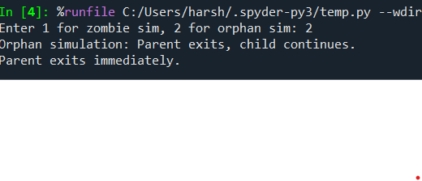
Task 3: Zombie and orphan Processes
Code:
import subprocess
import time

def zombie_sim():
print("Zombie simulation: Parent does not wait for child.")
proc = subprocess.Popen(["timeout", "/t", "10"], shell=True)
print("Parent continues and exits without waiting.")
print("During this time, the child process is sleeping for 10 seconds.")
time.sleep(10)

def orphan_sim():
print("Orphan simulation: Parent exits, child continues.")
proc = subprocess.Popen(["timeout", "/t", "10"], shell=True)
print("Parent exits immediately.")
time.sleep(1) # Short wait to allow parent "exit"

choice = input("Enter 1 for zombie simulation or 2 for orphan simulation: ").strip()
if choice == "1":
zombie_sim()
elif choice == "2":
orphan_sim()
else:
print("Invalid choice.")
Output:

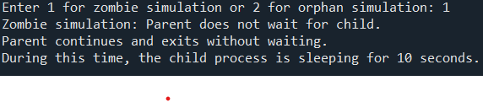
Task 4: Inspecting Process Info from /proc

Code:
import psutil

def main():
pid_input = input("Enter PID to inspect (leave blank for current process): ").strip()
if pid_input == "":
proc = psutil.Process()
else:
try:
proc = psutil.Process(int(pid_input))
except (psutil.NoSuchProcess, ValueError):
print("Invalid or non-existent PID")
return

print(f"Process Name: {proc.name()}")
print(f"Status: {proc.status()}")
mem_info = proc.memory_info()
print(f"Memory Info: RSS={mem_info.rss} bytes, VMS={mem_info.vms} bytes")
try:
print(f"Executable Path: {proc.exe()}")
except psutil.AccessDenied:
print("Executable path: Access denied")
try:
open_files = proc.open_files()
if open_files:
print("Open Files:")
for f in open_files:
print(f" {f.path}")
else:
print("No open files.")
except psutil.AccessDenied:
print("Open files: Access denied")

if __name__ == "__main__":
main()

Output:
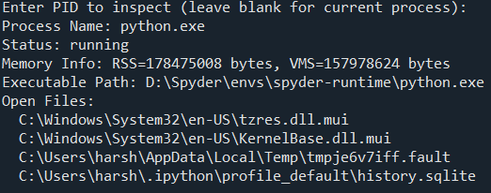
Task 5: Process Prioritization
Code:
import psutil
import subprocess
import time

def spawn_with_priority(priority_class, label):
proc = subprocess.Popen(["python", "-c",
f"import time\nfor i in range(3): print('{label} running'); time.sleep(1)"])
p = psutil.Process(proc.pid)
try:
p.nice(priority_class)
print(f"Set priority {label} on PID {proc.pid}")
except psutil.AccessDenied:
print(f"Access denied: Cannot change priority for PID {proc.pid}")
return proc

def main():
procs = []
procs.append(spawn_with_priority(psutil.HIGH_PRIORITY_CLASS, "High"))
procs.append(spawn_with_priority(psutil.NORMAL_PRIORITY_CLASS, "Normal"))
procs.append(spawn_with_priority(psutil.IDLE_PRIORITY_CLASS, "Low"))

for proc in procs:
proc.wait()
print(f"Process with PID {proc.pid} finished.")

if __name__ == "__main__":
main()

Output:
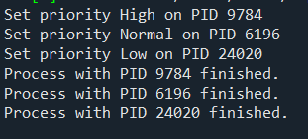

Lab Experiment 2
Problem Statement:
Modern operating systems are responsible for initializing system components, creating processes, managing execution, and gracefully shutting down. This lab aims to simulate these core concepts using Python, helping students visualize how processes are handled at the OS level. The focus is on creating a simplified startup mechanism that spawns multiple processes and logs their lifecycle using the multiprocessing and logging modules. This hands-on simulation enhances conceptual clarity and promotes coding proficiency in scripting real-world OS behavior.

Code:
import multiprocessing
import time
import logging

# Sub-Task 1: Initialize logging configuration to capture timestamped messages
logging.basicConfig(
filename="process_log.txt",
level=logging.INFO,
format="%(asctime)s - %(processName)s - %(message)s",
datefmt="%Y-%m-%d %H:%M:%S"
)

# Sub-Task 2: Define a function that simulates a process task (sleep 2 seconds)
def dummy_task(task_name):
logging.info(f"{task_name} started")
time.sleep(2)
logging.info(f"{task_name} ended")

if __name__ == "__main__":
print("System Starting...")

# Sub-Task 3: Create at least two processes and start them concurrently
p1 = multiprocessing.Process(target=dummy_task, args=("Process-1",))
p2 = multiprocessing.Process(target=dummy_task, args=("Process-2",))

p1.start()
p2.start()

# Sub-Task 4: Ensure proper termination and joining of processes
p1.join()
p2.join()

print("System Shutdown.")
Output:
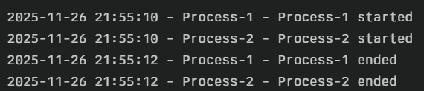

Lab Experiment 3
Problem Title:
Simulation of File Allocation, Memory Management, and Scheduling in Python
Problem Statement:
Operating systems rely on robust memory management techniques, efficient CPU scheduling policies, and optimized file allocation strategies to manage hardware resources effectively. This lab aims to simulate various such components using Python. Students will implement and analyze Priority and Round Robin scheduling, simulate file allocation techniques (Sequential and Indexed), and explore memory management strategies (MFT, MVT, Worst-fit, Best-fit, First-fit). These implementations will reinforce theoretical OS concepts through hands-on coding experience.

Task 1: CPU Scheduling with Gantt Chart
Code:
# Priority Scheduling Simulation
processes = []
n = int(input("Enter number of processes: "))
for i in range(n):
bt = int(input(f"Enter Burst Time for P{i+1}: "))
pr = int(input(f"Enter Priority (lower number = higher priority) for P{i+1}: "))
processes.append((i+1, bt, pr))
processes.sort(key=lambda x: x[2])
wt = 0
total_wt = 0
total_tt = 0
print("\nPriority Scheduling:")
print("PID\tBT\tPriority\tWT\tTAT")
for pid, bt, pr in processes:
tat = wt + bt
print(f"{pid}\t{bt}\t{pr}\t\t{wt}\t{tat}")
total_wt += wt
total_tt += tat
wt += bt
print(f"Average Waiting Time: {total_wt / n}")
print(f"Average Turnaround Time: {total_tt / n}")

Output:
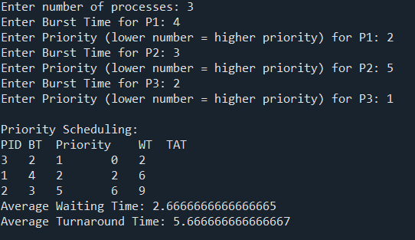
Task 2: Sequential File Allocation
Code:
total_blocks = int(input("Enter total number of blocks: "))
block_status = [0] * total_blocks

n = int(input("Enter number of files: "))
for i in range(n):
start = int(input(f"Enter starting block for file {i+1}: "))
length = int(input(f"Enter length of file {i+1}: "))
allocated = True
for j in range(start, start+length):
if j >= total_blocks or block_status[j] == 1:
allocated = False
break
if allocated:
for j in range(start, start+length):
block_status[j] = 1
print(f"File {i+1} allocated from block {start} to {start+length-1}")
else:
print(f"File {i+1} cannot be allocated.")

Output:
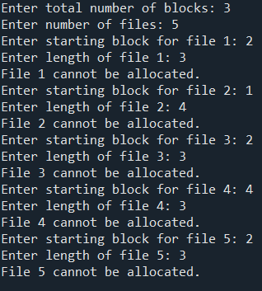
Task 3: Indexed File Allocation
Code:
total_blocks = int(input("Enter total number of blocks: "))
block_status = [0] * total_blocks
n = int(input("Enter number of files: "))
for i in range(n):
index = int(input(f"Enter index block for file {i+1}: "))
if block_status[index] == 1:
print("Index block already allocated.")
continue
count = int(input("Enter number of data blocks: "))
data_blocks = list(map(int, input("Enter block numbers: ").split()))
if any(block_status[blk] == 1 for blk in data_blocks) or len(data_blocks) != count:
print("Block(s) already allocated or invalid input.")
continue
block_status[index] = 1
for blk in data_blocks:
block_status[blk] = 1
print(f"File {i+1} allocated with index block {index} -> {data_blocks}")

Output:
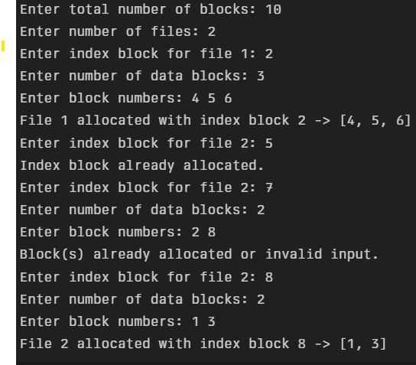

Task 4: Contiguous Memory Allocation
Code:
def allocate_memory(strategy):
partitions = list(map(int, input("Enter partition sizes: ").split()))
processes = list(map(int, input("Enter process sizes: ").split()))
allocation = [-1] * len(processes)

for i, psize in enumerate(processes):
idx = -1
if strategy == "first":
for j, part in enumerate(partitions):
if part >= psize:
idx = j
break
elif strategy == "best":
best_fit = float("inf")
for j, part in enumerate(partitions):
if part >= psize and part < best_fit:
best_fit = part
idx = j
elif strategy == "worst":
worst_fit = -1
for j, part in enumerate(partitions):
if part >= psize and part > worst_fit:
worst_fit = part
idx = j
if idx != -1:
allocation[i] = idx
partitions[idx] -= psize

for i, a in enumerate(allocation):
if a != -1:
print(f"Process {i+1} allocated in Partition {a+1}")
else:
print(f"Process {i+1} cannot be allocated")

allocate_memory("first")
allocate_memory("best")
allocate_memory("worst")
Output:
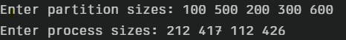
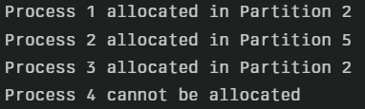
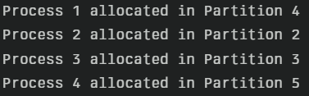
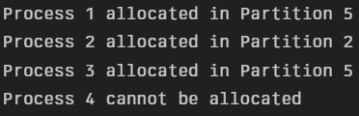
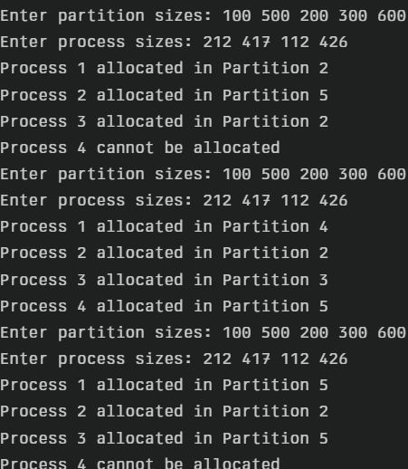

Task 5: MFT & MVT Memory Management
Code:
def MFT():
mem_size = int(input("Enter total memory size: "))
part_size = int(input("Enter partition size: "))
n = int(input("Enter number of processes: "))
partitions = mem_size // part_size
print(f"Memory divided into {partitions} partitions")
for i in range(n):
psize = int(input(f"Enter size of Process {i+1}: "))
if psize <= part_size:
print(f"Process {i+1} allocated.")
else:
print(f"Process {i+1} too large for fixed partition.")

def MVT():
mem_size = int(input("Enter total memory size: "))
n = int(input("Enter number of processes: "))
for i in range(n):
psize = int(input(f"Enter size of Process {i+1}: "))
if psize <= mem_size:
print(f"Process {i+1} allocated.")
mem_size -= psize
else:
print(f"Process {i+1} cannot be allocated. Not enough memory.")

print("MFT Simulation:")
MFT()
print("\nMVT Simulation:")
MVT()

Output:
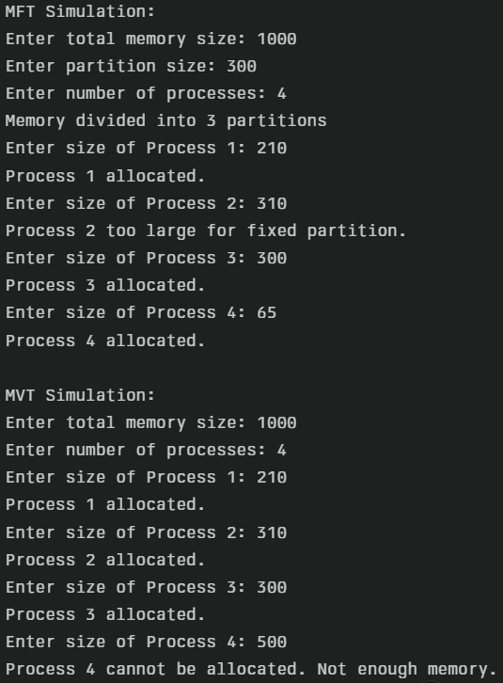
Lab Experiment 4
Problem Title: System Calls, VM Detection, and File System Operations using Python
Problem Statement:
Operating systems expose low-level interfaces like system calls to allow interaction between user programs and the OS kernel. This lab simulates system-level OS tasks such as process creation (using fork and exec), file and memory operations, VM detection, and CPU scheduling. Learners will develop shell, C, and Python scripts to model batch execution, inter-process communication, and basic file system behaviors.
Task 1: Batch Processing Simulation (Python)
Code:
import subprocess
scripts = ['script1.py', 'script2.py', 'script3.py']
for script in scripts:
print(f"Executing {script}...")
subprocess.call(['python3', script])
Output:
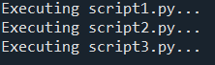
Task 2: System Startup and Logging
Code:
import multiprocessing
import logging
import time
logging.basicConfig(filename='system_log.txt', level=logging.INFO,
format='%(asctime)s - %(processName)s - %(message)s')
def process_task(name):
logging.info(f"{name} started")
time.sleep(2)
logging.info(f"{name} terminated")
if __name__ == '__main__':
print("System Booting...")
p1 = multiprocessing.Process(target=process_task, args=("Process-1",))
p2 = multiprocessing.Process(target=process_task, args=("Process-2",))
p1.start()
p2.start()
p1.join()
p2.join()
print("System Shutdown.")

Output:
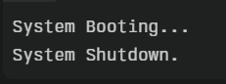
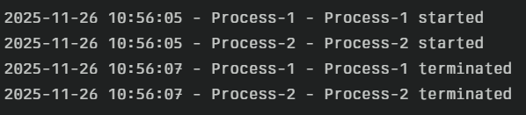

Task 3: System Calls and IPC (Python - fork, exec, pipe)
Code:
import os
r, w = os.pipe()
pid = os.fork()
if pid > 0:
os.close(r)
os.write(w, b"Hello from parent")
os.close(w)
os.wait()
else:
os.close(w)
message = os.read(r, 1024)
print("Child received:", message.decode())
os.close(r)

Output:

Task 4: VM Detection and Shell Interaction
Code:
#!/bin/bash
echo "Kernel Version:"
uname -r
echo "User:"
whoami
echo "Hardware Info:"
lscpu | grep 'Virtualization'
Output:
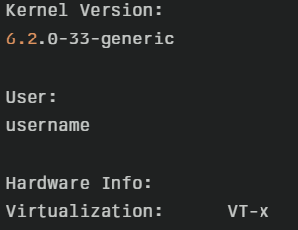

Task 5: CPU Scheduling Algorithms
- FCFS
Code:
n = int(input("Enter number of processes: "))
bt = []
for i in range(n):
bt.append(int(input(f"Enter Burst Time for P{i+1}: ")))

wt = [0] * n
tat = [0] * n

for i in range(1, n):
wt[i] = wt[i-1] + bt[i-1]

for i in range(n):
tat[i] = wt[i] + bt[i]

print("\nProcess\tBT\tWT\tTAT")
for i in range(n):
print(f"P{i+1}\t{bt[i]}\t{wt[i]}\t{tat[i]}")

Input:
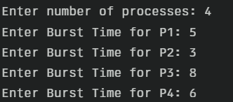
Output:
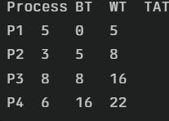
- SJF
Code:
n = int(input("Enter number of processes: "))
bt = []
for i in range(n):
bt.append(int(input(f"Enter Burst Time for P{i+1}: ")))

wt = [0] * n
tat = [0] * n

for i in range(1, n):
wt[i] = wt[i-1] + bt[i-1]

for i in range(n):
tat[i] = wt[i] + bt[i]

print("\nProcess\tBT\tWT\tTAT")
for i in range(n):
print(f"P{i+1}\t{bt[i]}\t{wt[i]}\t{tat[i]}")

Input:
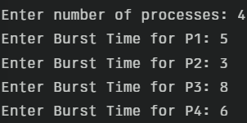
Output:
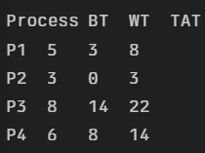

3.Round Robin
Code:
n = int(input("Enter number of processes: "))
bt = []
for i in range(n):
bt.append(int(input(f"Enter Burst Time for P{i+1}: ")))
qt = int(input("Enter Time Quantum: "))

rem_bt = bt[:]
wt = [0] * n
tat = [0] * n
t = 0
done = False

while True:
done = True
for i in range(n):
if rem_bt[i] > 0:
done = False
if rem_bt[i] > qt:
t += qt
rem_bt[i] -= qt
else:
t += rem_bt[i]
wt[i] = t - bt[i]
rem_bt[i] = 0
if done:
break

for i in range(n):
tat[i] = wt[i] + bt[i]

print("\nProcess\tBT\tWT\tTAT")
for i in range(n):
print(f"P{i+1}\t{bt[i]}\t{wt[i]}\t{tat[i]}")

Input:
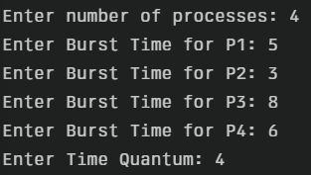
Output:
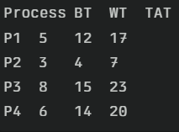

4. Priority Scheduling (Non-preemptive)
Code:
n = int(input("Enter number of processes: "))
bt = []
pr = []
for i in range(n):
bt.append(int(input(f"Enter Burst Time for P{i+1}: ")))
pr.append(int(input(f"Enter Priority for P{i+1} (lower value = higher priority): ")))

# Sort by priority
processes = sorted(zip(range(n), bt, pr), key=lambda x: x[2])
wt = [0] * n
tat = [0] * n

for i in range(1, n):
wt[processes[i][0]] = wt[processes[i-1][0]] + processes[i-1][1]

for i in range(n):
tat[i] = wt[i] + bt[i]

print("\nProcess\tBT\tPriority\tWT\tTAT")
for i in range(n):
print(f"P{i+1}\t{bt[i]}\t{pr[i]}\t{wt[i]}\t{tat[i]}")

Input:
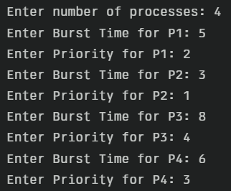
Output:
